Walking Speed Estimation Using an Accelerometer

CMPT353 Summer 2021

Sam Jia, Lillian liu, Lexi ke

2021

Introduction

Walking speed is an important tool used in various clinical studies such as gait analysis, evaluating the effectiveness of rehabilitation techniques, providing fall risk indicators, and so on. In order to obtain the walking speed, an inertial sensor such as an accelerometer or a gyroscope must be used. We choose to only use an accelerometer in this study to simplify the process since an accelerometer is more commonly accessible. However, most phone-based accelerometers contain lots of noises, these noises must be filtered out before proceeding to estimate walking speed from the data. Another point to note is that large inaccuracies may be generated while collecting data, this is due to the nature where error grows in proportion to time squared in accelerometers. To solve this problem, we will calculate the velocity in every stride cycle, then reset the speed to zero at the beginning of each new cycle. This way, errors in data will not build up as quickly and will not affect the accuracy of speed estimation greatly. The iPhone application ‘Accelerometer’ available for free in the iOS App Store will be used in this study. It is a free app with a recording feature and a choice to remove gravitational force from the measurements. **The purpose of this study is to find out whether accurate speed estimation can be achieved using just the accelerometer, and whether the location of the accelerometer affects the accuracy of the algorithm.**

Methods

**Participants:**

Due to the implications of COVID-19, participants will only be limited to group members of this project.

|  |  |
| --- | --- |
| Gender | Height |
| Male (Sam) | 186 cm |
| Female (Lillian) | 167 cm |
| Female (Lexi) | 160 cm |

Table1: Participant information

**Data Collection Methods:**

All raw data in this project is collected through the “Accelerometer” app on an iPhone 8 Plus device. We are determining whether the position of the phone affects the accuracy of the walking speed estimation. We will be testing three phone positions: in hand, in the pocket, and strapped to the subject’s calf as illustrated below:

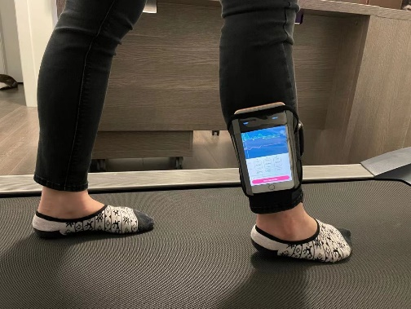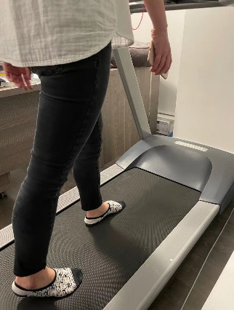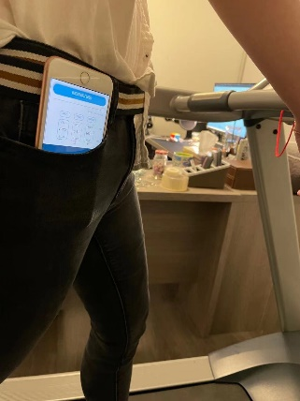

Figure 1: Subject holding the phone in hand   Figure 2: Subject phone in pocket   Figure 3: Subject phone strapped on the lower calf.

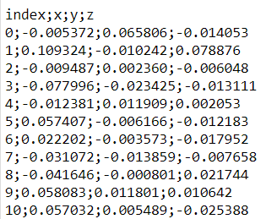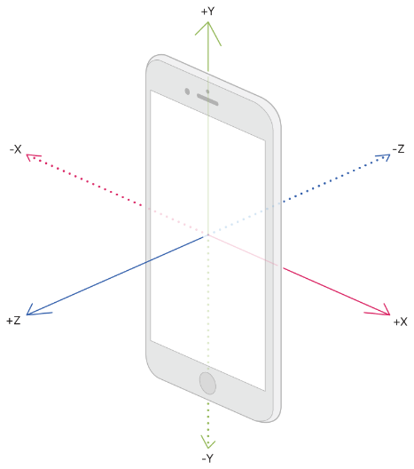The “Accelerometer” app records at a frequency of 25 Hz (records a data entry every 0.04 seconds). Gravity has been removed from the raw data by the app itself. Accelerations were measured in a triaxial way as shown in Figure 4. The raw data was recorded and saved as a CSV file with a format shown in Figure 5.

Figure 4: iPhone accelerometer measures changes in these three directions.                 Figure 5: Format of recorded CSV file. Only the top 10 rows are shown here.

After loading the CSV file into a Python Pandas DataFrame, column Z is dropped as it is not helpful in this project. When recording, the phone sways in a two-directional way, thus only x-axis and y-axis data recorded are valuable to us. The time between each data entry is 0.04 seconds, and the x and y data units are m/s². All three subjects walked on a treadmill for approximately 60 seconds with the treadmill’s speed set to 2.3 miles/hour, which converts to approximately 1.02 meters/second. However, each subject walks at a different pace, therefore the treadmill’s speed does not represent the subjects’ walking speed, it is simply the speed at which the treadmill’s belt is moving.

**Data Processing**

Filtering:

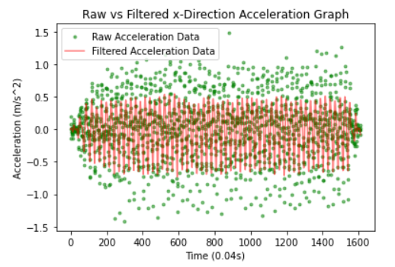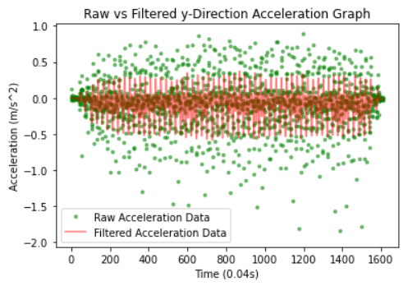Since the accelerometer does not remove noise, the data recorded must be processed before using them. The filter used in this experimentation is a low-pass digital Butterworth filter of degree 3. After many trials, we’ve decided that the best cut-off frequency is 0.192 since it removes most of the potential outliers in the data. We have tried other filters such as LOWESS smoothing filter and a band-pass analog Butterworth filter, results returned in both filters were not satisfactory as some outliers remain. Figure 8 and Figure 9 are the graphs demonstrating the filtered data (redline) vs raw data (green dots).

Figure 8 and Figure 9: Raw vs Butterworth Filtered data in both x and y directions.

Calculating:

From the filtered data, we tried to calculate the velocity through several mathematical formulas. First, we use the formula calculate the velocity of each row where is the final velocity and is the initial velocity, is the acceleration and is the time between two recorded data points. is initially set to zero. To simulate the initial velocity zero, we stood still on the treadmill for 3 seconds before each test and then began to accelerate after 3 seconds. Since acceleration can vary significantly during huge time intervals, we keep the time intervals small, as t = 0.04. Meanwhile, there are some unavoidable errors in data that grow in proportion to time squared in accelerators, so we need to reset the velocity to zero after each stride cycle. Therefore, we set a conditional statement to distinguish the beginning and end of a cycle. When the product of the current filtered data and the next filtered data is less than zero, we set the current initial velocity to zero. This is because every stride cycle begins with zero velocity and ends with zero velocity. After getting the velocity of the x-axis and y-axis, we calculate the final angular velocity through the Pythagorean formula.

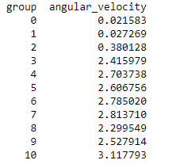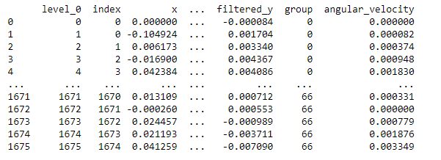Grouping:

Figure 10: Sample Output -- Grouping every 25 elements     Figure 11: Sample Output -- Summing the aggregated angular velocity

After calculating velocities corresponding to each filtered data point, we found that in order to obtain the most precise results for average velocity per second, we must “split” the dataset into small groups by assigning a unique group number. As mentioned earlier in the report, the “Accelerometer” app records at a frequency of 25 Hz (records a data entry every 0.04 seconds). Therefore, there are 25 data entries within 1 second (60s*0.04s=25), which means that to construct a 1-second-unit dataset, we put 25 consecutive data points into one group and sum them to get the velocity in a 1-second-unit. The main algorithm here uses modular operation and a special number which is 25. By doing the mod operation on the index of row entry with 25, all rows that have non-zero remainder are placed in one group. After encountering a row index that has zero remainders which is also the last member in the group, the group number is incremented by one. After summing all the grouped velocities to get the velocity in 1-second-units, calculate the average walking speed of the entire trial.  Here, the number of groups represents the running time of each experiment.

Results

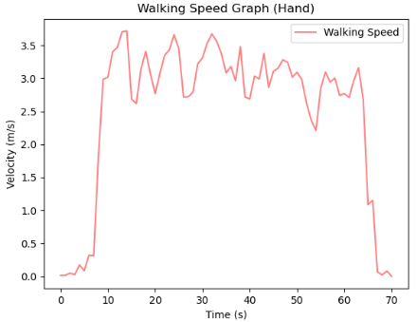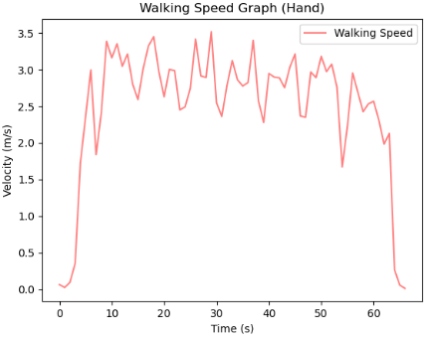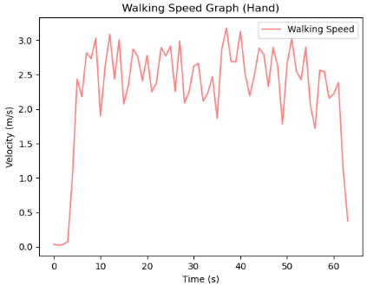**Data collected from the phone in hand:**

average speed is:  2.405306146609619 average speed is:  2.5839332238956607 average speed is:  2.589862101929209

Figure 12 - Lillian’s walking speed graph             Figure 13 - Lexi’s walking speed graph Figure 14 - Sam’s walking speed graph

This part of data is collected from the hand position and we select one of three datasets from each person as the sample output here. Even though three participants have different heights and walking strides, the average velocity is quite close (around 2.5m/s). From these three figures above, we know that all three people's velocity shares a similar behavior which starts from zero and rapidly grows to a non-zero number, and then it fluctuates up and down within an interval during the middle of the time and eventually quickly goes back to zero. The hand’s swaying motion is reflected by the graph. When a person walks forward, their hand also sways forward and back, represented by the local maximum and local minimum respectively.

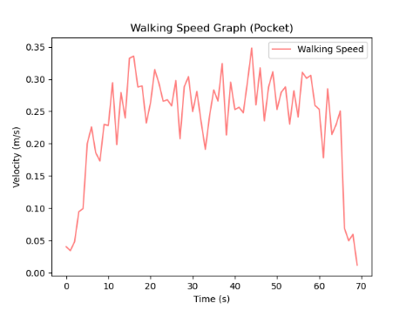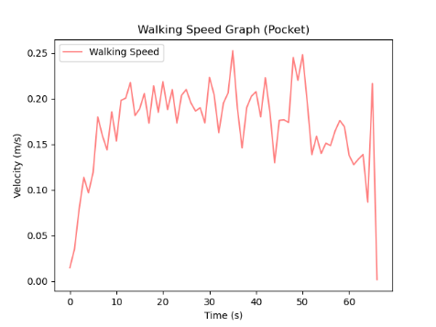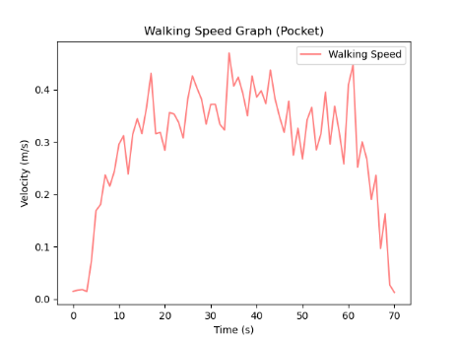**Data collected from phone in pocket:**

average speed is: 0.3282641928722863 average speed is:  0.19197967384312103 average speed is: 0.25295199747835806

Figure 15: Lillian’s walking speed graph.                         Figure 16: Lexi’s walking speed graph Figure 17: Sam’s walking speed graph

This part of data is collected from the phone positioned in the subjects’ pockets. It can be seen from the above figures that the changing trend of the broken line is similar to that of the data collected from the hand position, and the average speed of each person is also stable in a range of 0.17m/s to 0.29m/s. We believe that these figures are quite similar to each other in terms of its trend during the process of walking: from when the participant is stationary, so the speed starts from zero and then quickly increases to above zero after a few seconds, to when the participant stops walking, the speed returns to zero again, and there are continuous fluctuations in the middle of the movement, which represents that the participant keeps moving forward.

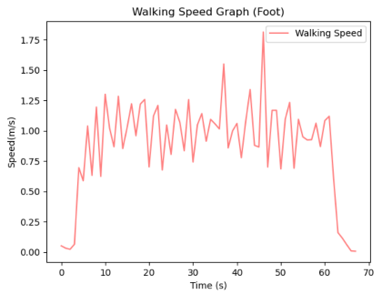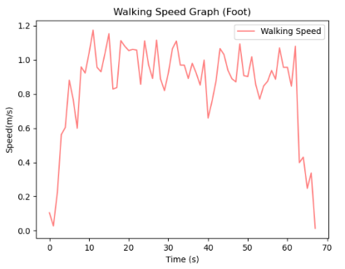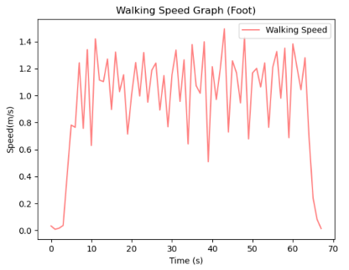**Data collected from phone strapped to lower calf:**

  average speed is: 1.035211537394916 average speed is:  1.1247286071305869 average speed is: 1.0910089772913196

Figure 18: Lillian’s walking speed graph.                      Figure 19: Lexi’s walking speed graph.  Figure 20: Sam’s walking speed graph.

This part of data is collected from the phone positioned at the subjects’ lower calf. The graph follows a similar trend as to the data collected from the hand position and pocket position: start at zero velocity, then climb up to normal walking speed, starts to alternate at a wavy-like form, then goes back down to zero towards the end. The average speed calculated from the data seems reasonable, around 1 m/s. The walking speed portrayed by the red line on the graph follows a trend that matches an average human’s gait: every peak is a step taken forward by the subject.

Discussion

Hand:

|  |  |  |  |
| --- | --- | --- | --- |
| ***Unit (m/s)*** | **Lillian** | **Lexi** | **Sam** |
| **The 1st trial** | 2.405306146609619 | 2.7915787672983 | 2.589862101929209 |
| **The 2nd trial** | 2.1820765516294975 | 2.5839332238956607 | 2.5423651180219555 |
| **The 3rd trial** | 2.160357634823464 | 2.351801187641 | 2.5252453276463154 |
| **Trial Average** | 2.249247 | 2.575771 | 2.552491 |

Table2: Average velocity returned by the program for each input file containing data recorded with the phone in hand.

According to the table above, the average velocity for three trials of each participant is above 2m/s which is far more than the average walking speed for an adult in their 20s according to healthline.com (between 1.34 and 1.36 m/s). For the occurrence of the above abnormal data, we speculate several possible causes of the problem:

* The amplitude of swing motion at which the hand is moving is different from that of which the leg is moving. For instance, sometimes the hand swings at a higher angle than the leg, thus swinging longer and causing the accelerometer to read and record more data in one direction.
* The frequency of swaying motion has an effect on calculating average velocity as well. We inspect every participant’s walking habits carefully before doing the trial. In terms of female members, Lexi’s arm has a higher swaying frequency than Lillian so that she can keep up with the pace set by the treadmill. Therefore, the frequency should be a reason that Lexi's overall average velocity is above Lillian’s.

Pocket:

|  |  |  |  |
| --- | --- | --- | --- |
| ***Unit (m/s)*** | **Lillian** | **Lexi** | **Sam** |
| **The 1st trial** | 0.3282641928722863 | 0.19135526948144196 | 0.25295199747835806 |
| **The 2nd trial** | 0.31041287371956794 | 0.19197967384312103 | 0.33383110558296103 |
| **The 3rd trial** | 0.280232931613857 | 0.20398919214475197 | 0.3589296086909601 |
| **Trial Average** | 0.306303 | 0.195775 | 0.315238 |

Table3: Average velocity returned by the program for each input file containing data recorded with the phone in pocket.

According to the table above, we found that the data measured at the pocket position ranged from 0.17m/s to 0.29m/s. Although the data trend was similar to that at other locations, the average velocity was far less than the normal walking velocity of an adult. In this regard, we think there are several possible reasons that should be taken into consideration:

* When the mobile phone is placed in the pocket, the swing of the mobile phone is much smaller than that of other positions. So, when the leg takes a step forward, the swing of the mobile phone in the pocket is less than that of the leg.
* Height is also the other important factor that makes the data fluctuate. When a taller person is walking, his/her legs swing with higher amplitude, which makes the displacement of the phone in the pocket larger. For example, Lexi's velocity is less than Sam's and Lillian’s.

Calf:

|  |  |  |  |
| --- | --- | --- | --- |
| ***Unit (m/s)*** | **Lillian** | **Lexi** | **Sam** |
| **The 1st Trial** | 1.1605633946559935 | 0.9669901336151665 | 0.952194563630152 |
| **The 2nd Trial** | 1.035211537394916 | 1.1247286071305869 | 1.0069188444990227 |
| **The 3rd Trial** | 1.0038283957664604 | 1.128973964235256 | 1.0910089772913196 |
| **The 4th  Trial** | 1.0279708774775218 | 1.197474537793728 | 1.0486355427438017 |
| **The 5th Trial** | 0.9777571021848979 | 1.3004605888392502 | 0.9745987410857588 |
| **Trial Average** | 1.04106626 | 1.143726 | 0.997853 |

Table4: Average velocity returned by the program for each input file containing data recorded with the phone in lower calf.

As shown in the table, this set of data represents the reasonable walking speed of an average 20-year-old human being. Although the treadmill is set to 1.02 m/s, this does not represent the actual velocity at which each participant walks at. Each participant’s walking behavior will affect their walking speed. Other factors such as height plays an important role in this as well.

* Everyone has their own unique walking habit. For example, Lexi walks at a slightly higher pace than Sam. One possible explanation could be that this is Lexi’s walking habit she formed when she had to walk to school every morning, compared to Sam who drove to school and did not have to walk as far and as fast as Lexi.
* Height is another factor that determines one’s walking speed. Taller people tend to have longer legs, causing a slower leg swing when walking. This is shown in Sam’s data as it is observed that he takes a longer time for each step.

Conclusion

After having a close look at each category’s data, the calf’s position is the most precise data source and it gives the most reasonable average velocity among all three positions. The hand position gives an average velocity of about 2.5m/s which is almost two times the calf’s position. Meanwhile, the pocket position’s average velocity is around 0.25m/s, which is approximately a quarter of the velocity calculated with input from calf position. The results vary depending on where the phone is. The pocket and hand data do not give a reasonable result, whereas data collected with the calf’s movement is much more accurate and resembles the walking speed of an average human being. Overall, accurate walking speed can be calculated from just an accelerometer strapped at a person’s lower calf.

Limitations

Due to COVID-19, this experiment could only be conducted within the group and on a treadmill. Under normal circumstances, this experiment would be carried out with a much larger group and on a track. Treadmill limits the range of speed at which a participant can walk: they cannot walk too fast or too slow than the treadmill speed. As shown before, according to healthline.com an average 20-year-old human being walks at 1.34 to 1.36 m/s. This could be reflected if participants walked outside on a real track at their own pace.

Another limitation is the devices used in this experiment. Only an iPhone accelerometer app was used to record data. The accuracy is not as good as a professional accelerometer sensor. In theory, a gyroscope should be used in combination with an accelerometer to determine the angular velocity, however, we were unable to find an app that allows the recording of gyroscope data and accelerometer data simultaneously.

Project Experience Summary

Lillian

* Designed a Python program in groups of three that can determine the average velocity of the participant by reading the output on 3-axis acceleration
* Gathered data from three different positions (hand, pocket and lower calf) to compare and contrast final results in the report
* Implemented splitting operation on datasets by assigning each entry a group number based on result from modular operation to minimize errors for subsequent average velocity calculation
* Constructed an academic report with concise description along with clear visualizations to better present the experiment and results

Sam

* Designed an algorithm to perform ETL on acceleration data and compute the corresponding average velocity in units of seconds.
* Learned how to manipulate different filters such as a lowpass Butterworth filter and a LOWESS smoothing filter to reduce noise of the raw data and remove potential outliers.
* Communicated the project’s targeting question, data collection, processing and analyzing method, results, and limitations through a thorough project report.

References

Cronkleton, E. (2019, March 14). Average Walking Speed: Pace, and Comparisons by Age and Sex. Retrieved from

<https://www.healthline.com/health/exercise-fitness/average-walking-speed#average-speed-by-age>

# Getting Raw Accelerometer Events. (n.d.). Retrieved August 13, 2021, from

# <https://developer.apple.com/documentation/coremotion/getting_raw_accelerometer_events>

Accelerometer app: <https://apps.apple.com/ca/app/accelerometer/id499629589>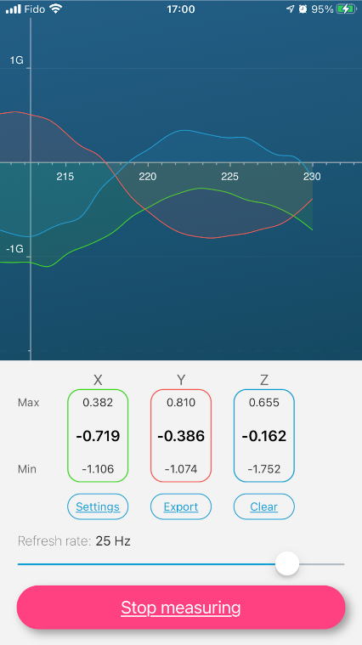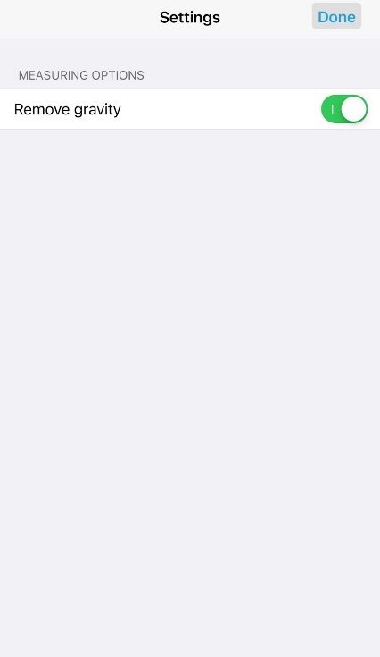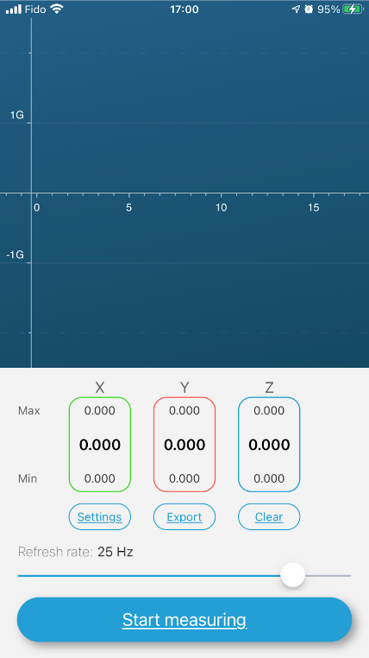

The “Accelerometer” app has straight-forward interface and we can adjust the refresh by swiping the progress bar at the bottom of the screen. It also provides the option to remove gravity in the Setting menu. By pressing the “Start measuring” button, the app records acceleration in 3-axis and it also displays the live graph to provide better visualization. After tapping the ‘Stop measuring’ button, the app stops recording and the data can be exported to a CSV file.